**Worksheet 6B: Testing (Part 2)**

Thi Van Anh DUONG Student ID: 90023112

Diploma of Information Technology, Curtin College

ISEN1000: Introduction to Software Engineering

Coordinator: Khurram Hameed

18 April 2022

## **Student Declaration of Originality**

|  |  |
| --- | --- |
|  | This assignment is my own original work, and no part has been copied from another student’s work or source, except where it is clearly attributed. |
|  | All facts/ideas/claims are from academic sources are paraphrased and cited/referenced correctly. |
|  | I have not previously submitted this work in any form for THIS or for any other unit; or published it elsewhere before. |
|  | No part of this work has been written for me by another person. |
|  | I recognise that should this declaration be found to be false, disciplinary action could be taken and penalties imposed in accordance with Curtin College policy. |

**Electronic Submission:**

|  |  |
| --- | --- |
|  | I accept that it is my responsibility to check that the submitted file is the correct file, is readable and has not been corrupted. |
|  | I acknowledge that a submitted file that is unable to be read cannot be marked and will be treated as a non-submission. |
|  | I hold a copy of this work if the original is damaged, and will retain a copy of the Turnitin receipt as evidence of submission. |

1. **Basic Test Code**

In testUniAdmin.py, testHouseCalc.py, testCharacterUtils.py, testHealthCalc.py

1. **Unittest Test Code**

In testUniAdmin++.py, testHouseCalc++.py, testCharacterUtils++.py, testHealthCalc++.py

1. **Debugging**

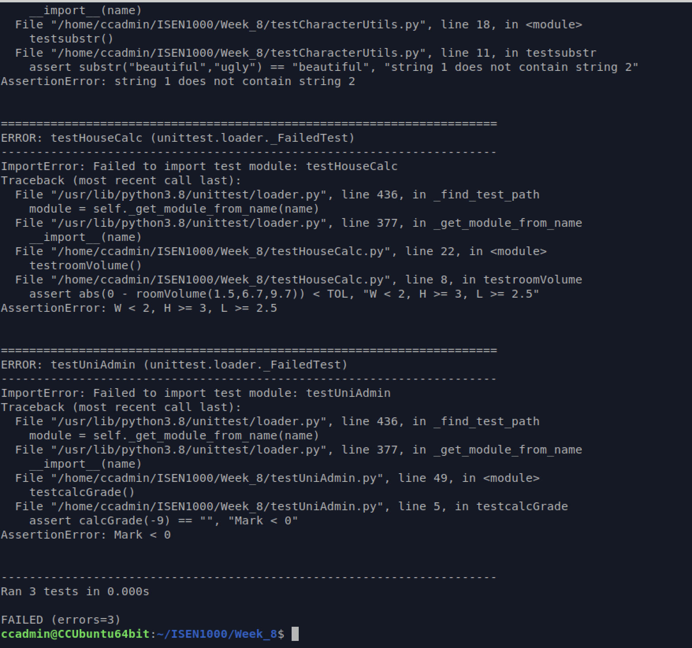

After designing testing code, I found 3 errors as above.

I can identity some of the faults in the production code and I have fixed them in UniAdminFixed.py, HouseCalcFixed.py, CharacterUtilsFixed.py, HealthCalcFixed.py.

Errors reduce from 3 to 1 error.

